Accounting
Cover Page

Assignment: Company Analysis

Your Name:

Course and Section:

Professor’s Name:

Date Completed:

AeroVironment
Company Analysis Loan Request
AeroVironment Inc. designs, develops, produces, supports and operates unmanned aircraft systems (UAS) and efficient energy systems (EES) in the United States and internationally. The company offers small UAS products to deliver intelligence, surveillance, and reconnaissance, and communication, such as real-time tactical reconnaissance, tracking, combat assessment, and geographic data to the small tactical unit or individual operator. Its small UAS wirelessly transmit critical live video and other information to a hand-held ground control unit enabling the operator to view and capture images; ground control systems allow the operator to control aircrafts; and tactical missile systems designed to reusable for flights under normal operating circumstances and can be recovered through an autonomous landing feature that enables a controlled descent to a designated location.

The firm’s balance sheets and income statements are provided herein. The company has 25,000 shares of common stock outstanding.
The firm’s CFO, Ms. Brenda Hiteck, has decided to seek a line of credit from your bank totaling $100,000.

This line of credit is necessary for the firm to get through its payable during hard times it is currently facing.

Your bank has decided to evaluate AeroVironment's financial statements to determine if it should establish a line of credit with the company. In addition, you will compare the company’s financial ratios with industry standards in order to make your determination.

Does your bank comply with the company’s request for the line of credit?
Provide a thorough discussion for your decision. It’s OK to think outside the box.

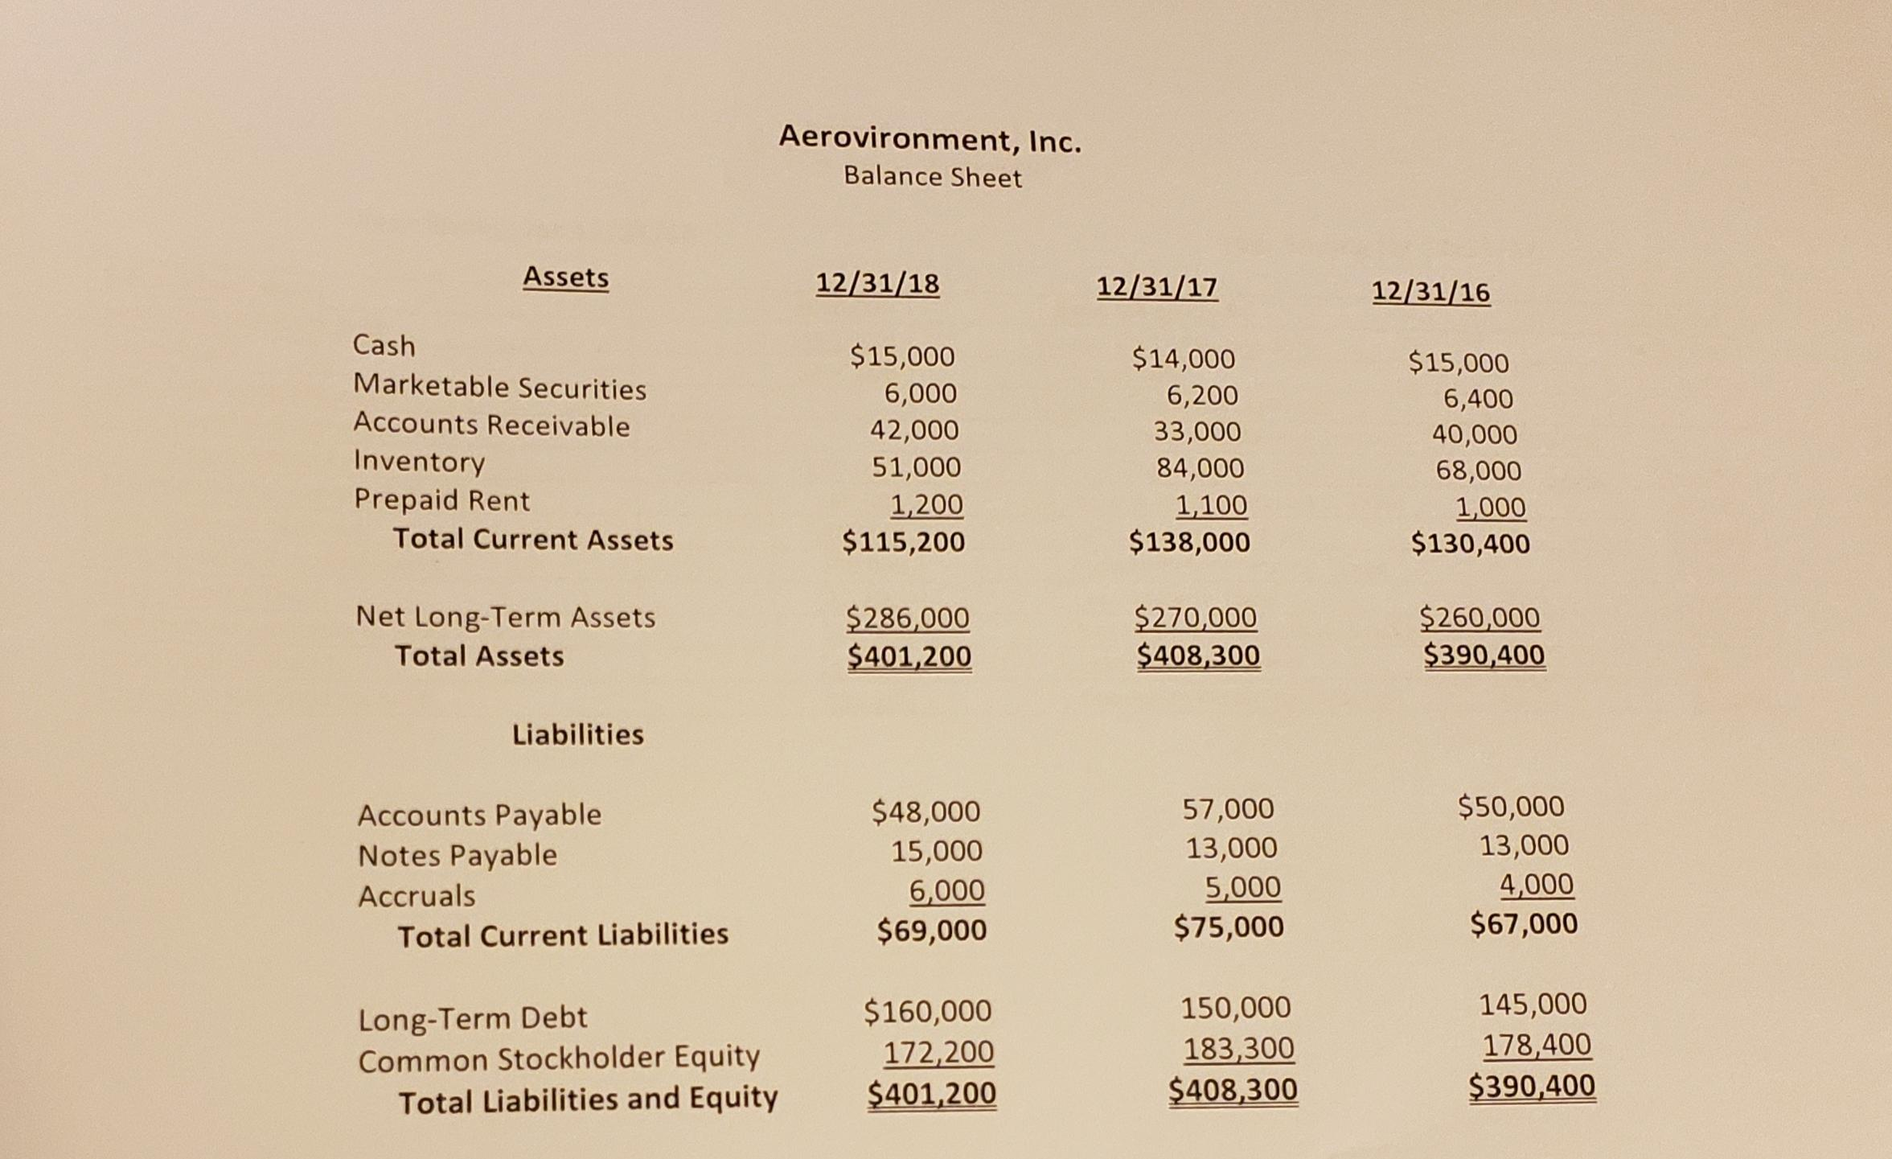

During each of the above years, the company has had only 25,000 shares of its common stock outstanding.

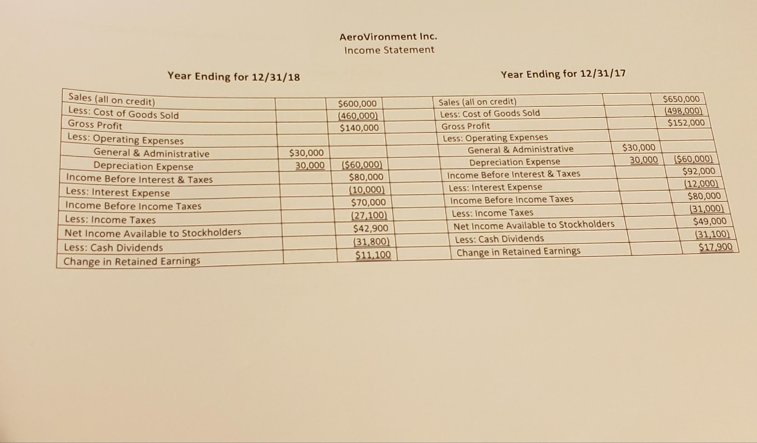

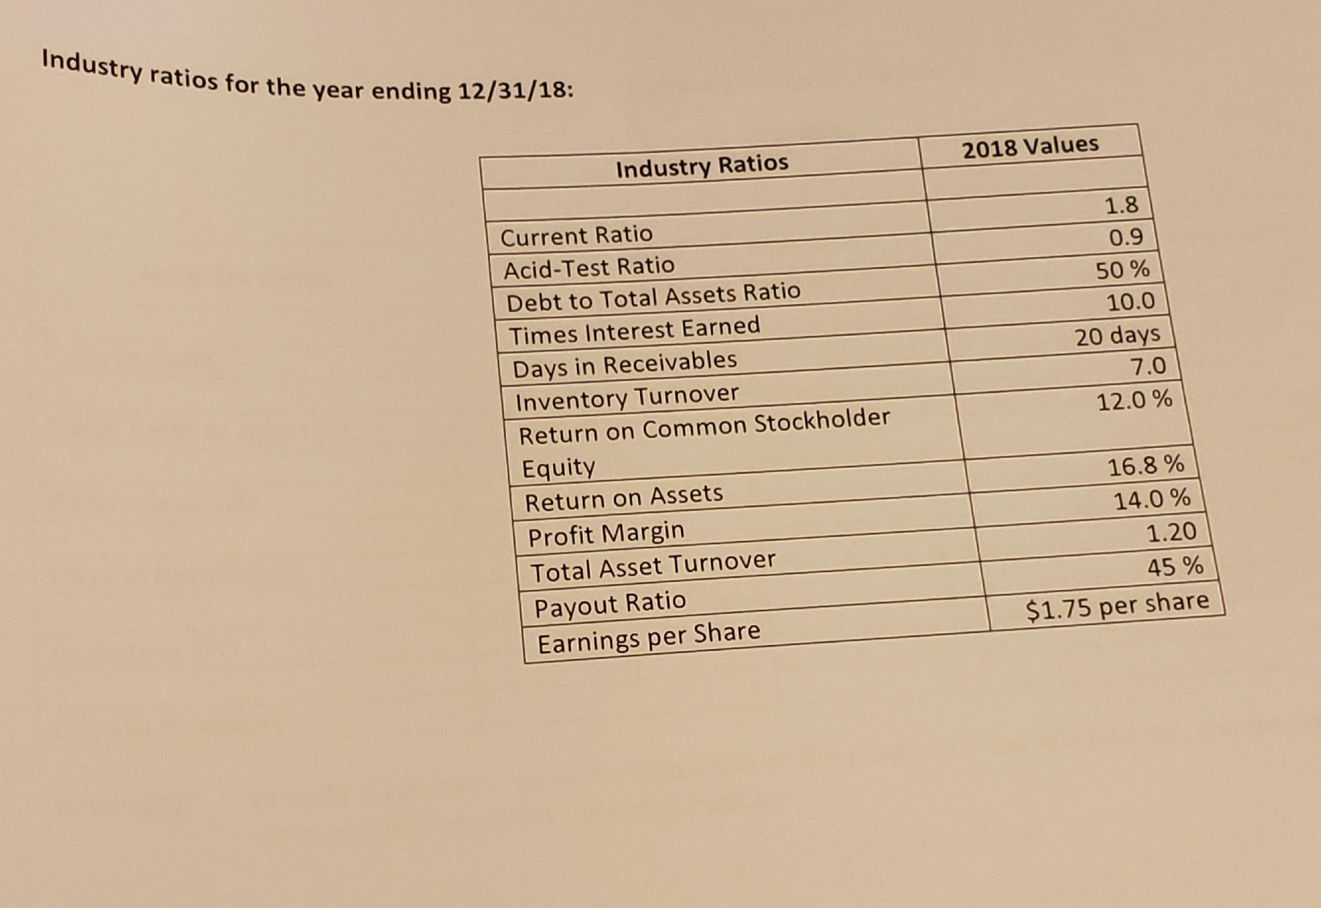

Company Analysis – Part 1 of 5
Liquidity

Liquidity Ratios | Current  Year | Prior  Year | Improved / Deteriorated | Comments
Current Ratio
Quick Ratio or Acid Test
Receivables T/O
Days in Receivables
Inventory T/O
Days in Inventory

Summary: Provide a 100 word minimum discussion on the purpose of liquidity analysis, and the conclusion you reached on the state
of your company’s liquidity position.

Company Analysis – Part 2 of 5
Profitability

Profitability Ratios | Current  Year | Prior  Year | Improved / Deteriorated | Comments
Profit Margin
Asset Turnover
Return on Assets
Return on C/S Holder Equity
Earnings per Share (EPS)
Price Earnings (P/E)
Payout Ratio

Summary: Provide a 100 word minimum discussion on the purpose of profitability analysis, and the conclusion you reached on the state
of your company’s profitability position.

Company Analysis – Part 3 of 5
Solvency

Solvency Ratios | Current  Year | Prior  Year | Improved / Deteriorated | Comments
Debt to Total Assets
Times Interest Earned

Summary: Provide a 100 word minimum discussion on the purpose of solvency analysis, and the conclusion you reached on the state
of your company’s solvency position.

Company Analysis – Part 4 of 5
Vertical Analysis (Common Sizing)
Income Statement

Industry Ratios | Industry Values | 2018  Company Values | Comments
Current Ratio | 1.8
Acid-Test Ratio | 0.9
Debt to Total Assets Ratio | 50%
Times Interest Earned | 10.0
Days in Receivables | 20 days
Inventory Turnover | 7.0
Return on Common Stockholder Equity | 12.0%
Return on Assets | 16.8%
Profit Margin | 14.0%
Total Asset Turnover | 1.20
Payout Ratio | 45%
Earnings per Share | $1.75 per share
Amount in millions _____ thousands_____

Summary: Provide a 100 word minimum discussion on the purpose of vertical analysis, and the conclusion you reached on the state
your AeroVironment's industry analysis.

Company Analysis – Part 5 of 6

Will you give the company a line of credit? Justify your decision based on your analysis

(Thoroughly discuss the reasons why, relative to the analysis you performed on AeroVironment. Do not speculate on something you did not evaluate and don’t base any conclusion on feelings. There is no room for feelings when analyzing companies).

